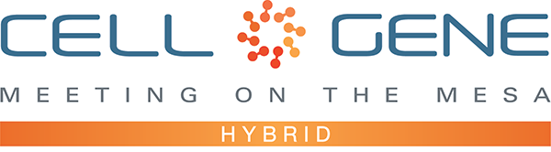

Dear Meeting on the Mesa Registrants,

Thank you for joining us this year for our hybrid event! We’re looking forward to engaging with you at the conference and via ARM’s social media channels.

We hope that you’ll use this media kit to share your experiences at the Meeting on the Mesa via your personal Twitter and LinkedIn accounts, as well as with your colleagues who run your organization’s official social media channels. Leveraging social media should also help you and your organization maximize the number of meetings you can set up via the partnering software.

We’ve included some suggested text for tweets and posts below to get you started – but feel free to draft your own! Remember to use the hashtag #CGMesa21 and tag the Alliance for Regenerative Medicine (@alliancerm on Twitter and @Alliance for Regenerative Medicine on LinkedIn). We’ve included a banner for the conference in this media kit that you can include with your posts.

If you plan to share any video recordings from the Meeting on the Mesa, please contact Kaitlyn Dupont (kdupont@alliancerm.org) for prior approval.

Finally, if you haven’t yet, make sure you’re following ARM to stay up to date on all the action. We’ll be live on social media throughout the meeting, and we have some exciting teasers we’ll be sharing in the weeks leading up.

Twitter: @alliancerm (https://twitter.com/alliancerm)
LinkedIn: Alliance for Regenerative Medicine (https://www.linkedin.com/company/802138)

If you have any questions about this media kit, please reach out to Kaitlyn Dupont (kdupont@alliancerm.org).

Whether you’re joining us in-person or virtually this year, we’re excited to bring you both the expert insights and extensive partnering opportunities the Meeting on the Mesa is known for.

Warm regards,
The ARM Team
Suggested Posts for Twitter & LinkedIn
Date | Twitter | LinkedIn
October 4-8 | [X] days until @alliancerm’s #CGMesa21! The hybrid event includes in-person programming Oct. 12-14 & virtual partnering Oct. 19-20. Join the #cellandgenetherapy sector's foremost annual conference: https://meetingonthemesa.com/ | [x] days until @Alliance for Regenerative Medicine’s 2021 Cell & Gene Meeting on the Mesa! Join me from October 12-14 for in-person programming & October 19-20 for two additional days of virtual partnering. This virtual event, bringing together senior executives & top decision-makers in the industry to advance the cutting-edge regenerative medicine and advanced therapies sector. For more information, visit https://meetingonthemesa.com/  #CGMesa21 #RegenerativeMedicine #AdvancedTherapies
October 4-8 | [Company] is attending @alliancerm’s #CGMesa21! 3,000+ virtual and in-person partnering meetings will take place Oct. 12-14 & 19-20 – register to set up a meeting with our team: https://meetingonthemesa.com/ | [Company] is attending the @Alliance for Regenerative Medicine’s Cell & Gene Meeting on the Mesa! Organizers are expecting 3,000+ virtual and in-person partnering meetings to be scheduled during the conference, which will take place October 12-14 and 19-20. The partnering system is open – set up a meeting with our team now! For more information, visit https://meetingonthemesa.com/  #CGMesa21 #RegenerativeMedicine #AdvancedTherapies
October 11 | Excited for Day 1 of @alliancerm’s Cell & Gene Meeting on the Mesa tomorrow! Check out the exciting line up of in-person and online content during this hybrid conference: https://meetingonthemesa.com/ #CGMesa21 | Excited for Day 1 of the @Alliance for Regenerative Medicine’s Cell & Gene Meeting on the Mesa tomorrow! This meeting brings together senior executives & top decision-makers to advance this cutting-edge sector. Check out the exciting line up of in-person and virtual content from key policymakers, industry, and more: https://meetingonthemesa.com/  #CGMesa21 #RegenerativeMedicine #AdvancedTherapies
October 12 | Good morning fellow conference attendees! Day 1 of @alliancerm’s Cell & Gene Meeting on the Mesa is underway. Looking forward to seeing everyone [virtually/in-person] this week! It’s not too late to register: https://meetingonthemesa.com/ #CGMesa21 | Good morning fellow conference attendees! Day 1 of the @Alliance for Regenerative Medicine’s Cell & Gene Meeting on the Mesa is underway. Looking forward to seeing everyone [virtually/in-person] this week! It’s not too late to register: https://meetingonthemesa.com/  #CGMesa21 #RegenerativeMedicine #AdvancedTherapies
October 13-14 | Excited to hear from #cellandgenetherapy sector leaders at @alliancerm’s #CGMesa21 today! Recordings will be available online for registrants. Don’t forget to check out the exciting line up of in-person & online content: https://meetingonthemesa.com/ | I’m excited to hear from #cellandgenetherapy sector leaders at @Alliance for Regenerative Medicine’s Cell & Gene Meeting on the Mesa today! Recordings of the content from the meeting will be available for registrants. Don’t forget to check out the exciting line up of in-person and online content at the meeting: https://meetingonthemesa.com/  #CGMesa21 #RegenerativeMedicine #AdvancedTherapies
October 19  Virtual partnering day | We’re back online for @alliancerm’s #CGMesa21! With two days of virtual partnering, there’s still time to schedule a meeting with our team: https://meetingonthemesa.com/ | We’re back online for @Alliance for Regenerative Medicine’s Cell & Gene Meeting on the Mesa! With two days of virtual partnering, there’s still time to schedule a meeting with our team: https://meetingonthemesa.com/  #CGMesa21 #RegenerativeMedicine #AdvancedTherapies
October 20  Virtual partnering day | It's the final day of virtual partnering at @alliancerm's #CGMesa21. Thank you to everyone who made this conference a success! Recordings are available online if you missed any of the insightful content: https://meetingonthemesa.com/ | It’s the final day of virtual partnering at @Alliance for Regenerative Medicine’s Cell & Gene Meeting on the Mesa! Thank you to the presenters, organizers, and to our fellow attendees for making this conference a success! Recordings are available online if you missed any of the insightful content: https://meetingonthemesa.com/  #CGMesa21 #RegenerativeMedicine #AdvancedTherapies

Social Media Posts:

Use the following banner with your Twitter and LinkedIn posts! Right click on the banner and click “Save as Picture,” or download it here.

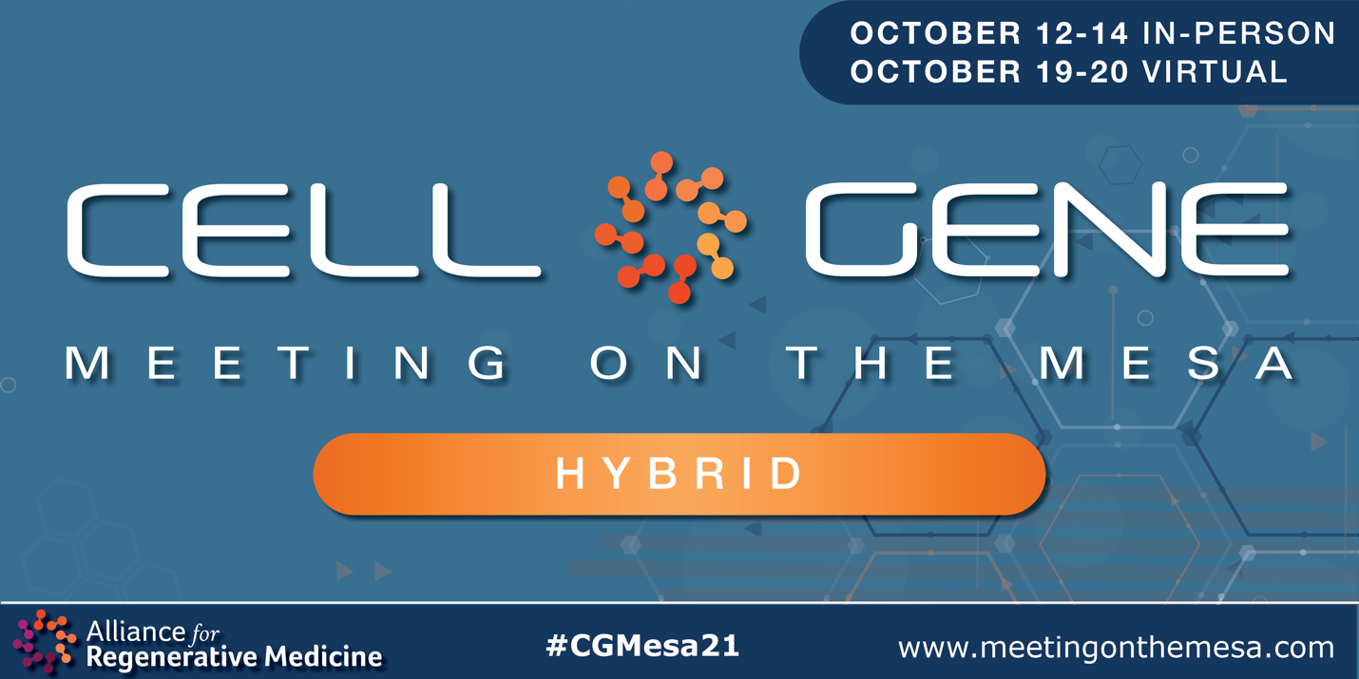

Email Signature Banners:

Use the following banner in your email signature to let you colleagues, clients, and partners know that you’re attending! Right click on the banner and click “Save as Picture,” or download it here.

