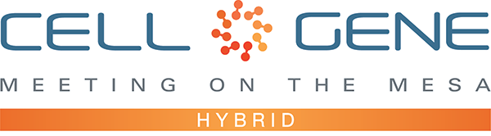

Dear Panelists,

Thank you for participating in ARM’s 2021 Meeting on the Mesa! We’re looking forward to engaging with you at the conference and via ARM’s social media channels.

We hope that you’ll use this media kit to promote your panel and share your experiences at the Meeting on the Mesa via your personal Twitter and LinkedIn accounts. We also encourage you to share this information with your colleagues who run your organization’s official social media channels. Leveraging social media can also help you and your organization maximize the number of meetings you can set up via the partnering software.

We’ve included some suggested text for tweets and posts below to get you started – but feel free to draft your own! Remember to use the hashtag #CGMesa21 and tag the Alliance for Regenerative Medicine (@alliancerm on Twitter and @Alliance for Regenerative Medicine on LinkedIn). We’ve included a banner for the conference in this media kit that you can include with your posts, as well as a link to some customizable options allowing you to add your company logo, headshot, and other information.

If you plan to share any video recordings from the Meeting on the Mesa, please contact Kaitlyn Dupont (kdupont@alliancerm.org) for prior approval.

Finally, if you haven’t yet, make sure you’re following ARM to stay up to date on all of the action. We’ll be live on social media throughout the meeting, and we have some exciting teasers we’ll be sharing in the weeks leading up.

Twitter: @alliancerm (https://twitter.com/alliancerm)
LinkedIn: Alliance for Regenerative Medicine (https://www.linkedin.com/company/802138)

If you have any questions about this media kit, please reach out to Kaitlyn Dupont (kdupont@alliancerm.org).

Whether you’re joining us in-person of virtually this year, we’re excited to bring you both the expert insights and extensive partnering opportunities the Meeting on the Mesa is known for.

Warm regards,
The ARM Team
Suggested Posts for Twitter & LinkedIn
Date | Twitter | LinkedIn
October 4-8  Company social | [Name] will be participating in a panel on [panel title] at @alliancerm’s #CGMesa21 next week! Don’t miss out – register for this meeting taking place Oct 12-14 & 19-20: https://meetingonthemesa.com/ | [Name] will be participating in a panel on [panel title] at @Alliance for Regenerative Medicine’s Cell & Gene Meeting on the Mesa! With in-person programming October 12-14 and virtual partnering October 19-20, this hybrid meeting brings together senior executives & top decision-makers to advance this cutting-edge sector. Don’t miss out – for more information, visit https://bit.ly/39kYQIR.  #CGMesa21 #RegenerativeMedicine #AdvancedTherapies
October 4-8  Personal social | I’m looking forward to participating in a panel on [panel title] at @alliancerm’s #CGMesa21 next week! I hope you’ll join me at the virtual meeting, taking place Oct 12-14 & 19-20: https://meetingonthemesa.com/ | I’m excited to be participating in a panel on [panel title] at @Alliance for Regenerative Medicine’s Cell & Gene Meeting on the Mesa! With in-person programming October 12-14 and virtual partnering October 19-20, this hybrid meeting brings together senior executives & top decision-makers to advance this cutting-edge sector. Don’t miss out – for more information, visit https://bit.ly/39kYQIR.  #CGMesa21 #RegenerativeMedicine #AdvancedTherapies
October 11  Company social | Excited for the kick-off of @alliancerm’s #CGMesa21 tomorrow! Check out the exciting line up of in-person and online content during the conference – including a panel on [panel title]: https://meetingonthemesa.com/ | We’re excited for the kick-off of @Alliance for Regenerative Medicine’s Cell & Gene Meeting on the Mesa tomorrow! Check out the exciting line up of in-person and online content from key policymakers, industry, and more – including a panel on [panel title]: https://bit.ly/301fidI  #CGMesa21 #RegenerativeMedicine #AdvancedTherapies
October 11  Personal social | I’m excited to discuss [panel title] this week at @alliancerm’s #CGMesa21! My panel will take place [date]. Don’t forget to register: https://meetingonthemesa.com/ | I’m excited to discuss [panel title] this week at @Alliance for Regenerative Medicine’s Cell & Gene Meeting on the Mesa! My panel will take place [date]. Don’t forget to register: https://bit.ly/39kYQIR.  #CGMesa21 #RegenerativeMedicine #AdvancedTherapies
Day of panel  Company social | [Name] is discussing [panel] title in a panel at @alliancerm’s Cell & Gene Meeting on the Mesa! Tune in at [time] today: https://meetingonthemesa.com/ #CGMesa21 | [Name] is discussing [panel] title in a panel at @Alliance for Regenerative Medicine’s Cell & Gene Meeting on the Mesa! Tune in at [time] today: https://meetingonthemesa.com/  #CGMesa21 #RegenerativeMedicine #AdvancedTherapies
Day of panel  Personal social | It’s great to have the opportunity to discuss [panel title] with my colleagues at @alliancerm’s #CGMesa21! If you missed the panel, watch the recording online online: https://meetingonthemesa.com/ | It’s great to have the opportunity to discuss [panel title] with my colleagues at @Alliance for Regenerative Medicine’s Cell & Gene Meeting on the Mesa! If you missed the panel, watch the recording online: https://meetingonthemesa.com/  #CGMesa21 #RegenerativeMedicine #AdvancedTherapies
Post-meeting  Company social | Content from @alliancerm’s Cell & Gene Meeting on the Mesa will be available for registrants through EOY 2021! Don’t forget to check out [name] in the panel on [panel title]: https://meetingonthemesa.com/ #CGMesa21 | Content from @Alliance for Regenerative Medicine’s Cell & Gene Meeting on the Mesa will be available for registrants through EOY 2021! Don’t forget to check out [name] in the panel on [panel title]: https://meetingonthemesa.com/  #CGMesa21 #RegenerativeMedicine #AdvancedTherapies
Post-meeting  Personal social | If you didn’t have a chance to check out my panel on [panel title] at @alliancerm’s Cell & Gene Meeting on the Mesa, it will be available for registrants through EOY 2021! https://meetingonthemesa.com/#CGMesa21 | If you didn’t have a chance to check out my panel on [panel title] at @Alliance for Regenerative Medicine’s Cell & Gene Meeting on the Mesa, it will be available for registrants through EOY 2021! https://meetingonthemesa.com/  #CGMesa21 #RegenerativeMedicine #AdvancedTherapies

For more ideas on capitalizing your social media presence during the meeting, check out our Mesa attendees media kit.

Social Media Posts:

Use the following banner with your Twitter and LinkedIn posts! Right click on the banner and click “Save as Picture.” You can also easily generate custom banners featuring your company’s logo and/or a headshot of the panelist – download our panelist media kit banners here for instructions.

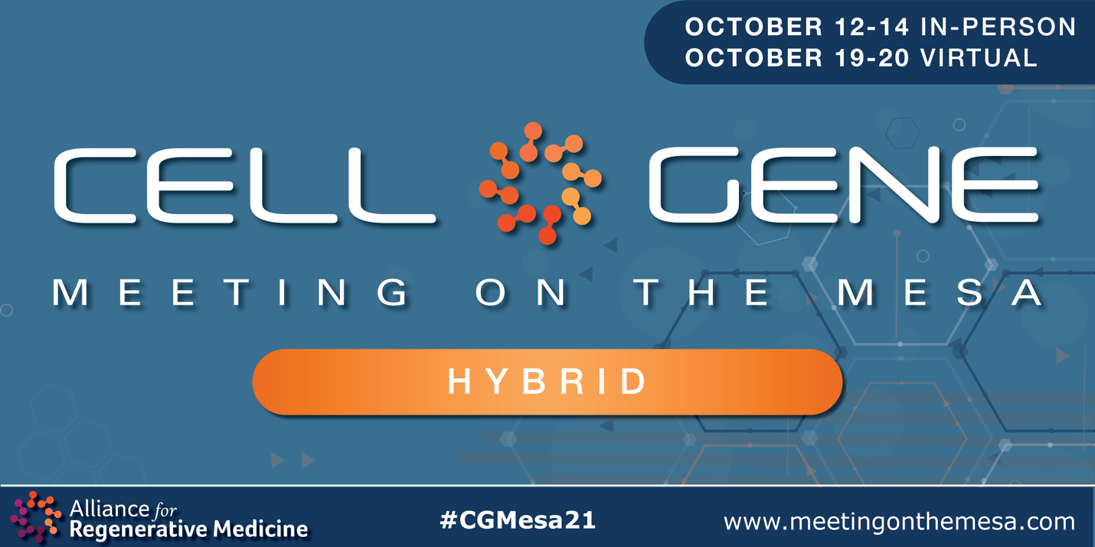

Email Signature Banners:

Use the following banner in your email signature to let you colleagues, clients, and partners know that you’re attending! Right click on the banner and click “Save as Picture,” or download it here.

