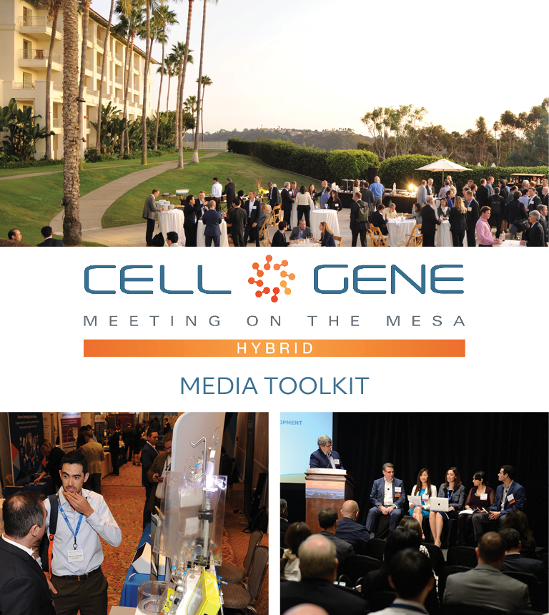

October 11 – 13, 2022 | Carlsbad, CA
#CGMesa22
What is this Toolkit?

Thank you for joining us this year! We’re looking forward to welcoming you to the cell and gene therapy sector’s leading gathering in North America.

This toolkit is meant to help you get the most out of #CGMesa22. Whether it’s showcasing your company’s panel, highlighting your speakers, or just showing off how much fun your team is having, engaging with the conference online is a great way to get visibility within the cell and gene therapy sector. Using social media will also help your organization maximize the number of meetings you can set up via the partnering software.

How to Follow the Conversation

First, make sure you’re following the Alliance for Regenerative Medicine (ARM) to stay up to date on all the action. We’ll be live on social media throughout the meeting, and we have some exciting teasers we’ll be sharing in the weeks leading up.

Twitter: @alliancerm (https://twitter.com/alliancerm)
LinkedIn: Alliance for Regenerative Medicine (https://www.linkedin.com/company/alliancerm)

Follow the conversation with #CGMesa22. Other related hashtags are #RegenerativeMedicine, #CellTherapy and #GeneTherapy. If you plan on using a different hashtag, give us a tweet to let us know!

Share Your Experience Online

There are many ways you can engage digitally at #CGMesa22!

- Like taking photographs? Post daily photos of your team at the conference.
- Are you a wordsmith? Give a readout of panels where your staff took part.
- Are you a talker? Post recordings of your team members sharing their favorite moments from the day. (Just don’t interrupt the speakers, please!)
  - Please note, if you plan to share any video recordings of the live sessions, please contact Adam Wolf (awolf@alliancerm.org) for prior approval.

We’ve included some suggested text for tweets and posts below to get you started – but feel free to draft your own! We’ve included a banner for the conference in this media kit that you can include with your posts.

Activate Others

Remember to use the hashtag #CGMesa22 and tag the Alliance for Regenerative Medicine (@alliancerm on Twitter and @Alliance for Regenerative Medicine on LinkedIn). Also tag your fellow colleagues to include them in the conversation!

Whether you’re joining us in-person or virtually this year, we’re excited to bring you both expert insights and unmatched partnering opportunities.

If you have any questions about this media toolkit, please reach out to Adam Wolf (awolf@alliancerm.org).

Suggested Posts for Twitter & LinkedIn
Date | Twitter | LinkedIn
October 3-7  Personal or company social | [X] days until @alliancerm’s #CGMesa22! The hybrid event includes in-person programming Oct. 11-13 & virtual partnering Oct. 18-19. Join [Company] at the cell and gene therapy sector's foremost annual conference: https://meetingonthemesa.com/ | [x] days until @Alliance for Regenerative Medicine’s 2022 Cell & Gene Meeting on the Mesa! Our team is excited to attend alongside senior executives & top decision-makers in the regenerative medicine and advanced therapies sector. Interested in joining us? Learn more here: https://meetingonthemesa.com/  #CGMesa22 #RegenerativeMedicine
October 3-7  Personal or company social | [Company] is looking forward to attending @alliancerm’s #CGMesa22! 3,000+ virtual and in-person partnering meetings will take place Oct. 11-13 & 18-19. Check out the action-packed agenda today: https://meetingonthemesa.com/ | [Company] is attending the @Alliance for Regenerative Medicine’s Cell & Gene Meeting on the Mesa! We look forward to connecting with 3,000+ leading experts at the conference, which will take place October 11-13, with virtual partnering October 18-19. Check out the action-packed agenda today: https://meetingonthemesa.com/  #CGMesa22 #RegenerativeMedicine
October 10  Personal or company social | Excited for Day 1 of @alliancerm’s Cell & Gene Meeting on the Mesa tomorrow! Check out the action-packed line-up featuring leading experts including a presentation from [company]:https://meetingonthemesa.com/ #CGMesa22 | Excited for Day 1 of the @Alliance for Regenerative Medicine’s Cell & Gene Meeting on the Mesa tomorrow! This conference brings together senior executives & top decision-makers to advance the cell and gene therapy sector. Check out the action-packed agenda which also includes a presentation from [company]: https://meetingonthemesa.com/  #CGMesa22 #RegenerativeMedicine
October 11-13  Personal or company social | The @Alliancerm’s #CGMesa22 is underway! We are thrilled to be delivering a company presentation [presentation date and time].  [Upload a photo or selfie!] | The @Alliance for Regenerative Medicine’s Cell & Gene Meeting on the Mesa is underway! We are thrilled to be delivering a company presentation [presentation date and time].  #CGMesa22 #RegenerativeMedicine  [Upload a photo or selfie!]
October 11-13  Personal or company social | It’s a great line up this year at @alliancerm’s Cell & Gene Meeting on the Mesa! Check out [Company’s] presentation, available on-demand all week: https://meetingonthemesa.com/ #CGMesa22 | It’s a great line up this year at @Alliance for Regenerative Medicine’s Cell & Gene Meeting on the Mesa! Check out [Company’s] presentation, available on-demand all week: https://meetingonthemesa.com/  #CGMesa22 #RegenerativeMedicine
October 13 | It is already the final day of @alliancerm’s #CGMesa22!  We were so thrilled to hear from cell and gene therapy sector leaders this week, including our very own [Give a shoutout to panelists from your company].  [Attach photos of your staff in action at the conference. Encourage them to share them with you.] | It is already the final day of @alliancerm’s #CGMesa22!  We were so thrilled to hear from cell and gene therapy sector leaders this week, including our very own [Give a shoutout to panelists from your company].  [Attach photos of your staff in action at the conference. Encourage them to share them with you.]
Post-meeting  Personal or company social | If you didn’t have a chance to check out [Company’s] presentation at @alliancerm’s Cell & Gene Meeting on the Mesa, it’s not a problem – content from the meeting will be available for registrants through 2022! https://meetingonthemesa.com/ #CGMesa22 | If you didn’t have a chance to check out [Company’s] presentation at @Alliance for Regenerative Medicine’s #CGMesa22, it’s not a problem – content from the meeting will be available for registrants through 2022! Check it out now: https://meetingonthemesa.com/  #CGMesa22 #RegenerativeMedicine
October 18  Virtual partnering day | We’re back online for @alliancerm’s #CGMesa22! With two days of virtual partnering, there’s still time to schedule a meeting with our team: https://meetingonthemesa.com/ | We’re back online for @Alliance for Regenerative Medicine’s Cell & Gene Meeting on the Mesa! With two days of virtual partnering, there’s still time to schedule a meeting with our team: https://meetingonthemesa.com/  #RegenerativeMedicine #CGMesa22

Social Media Posts:

Use the following banner with your Twitter and LinkedIn posts! Right click on the banner and click “Save as Picture,” or download it here.

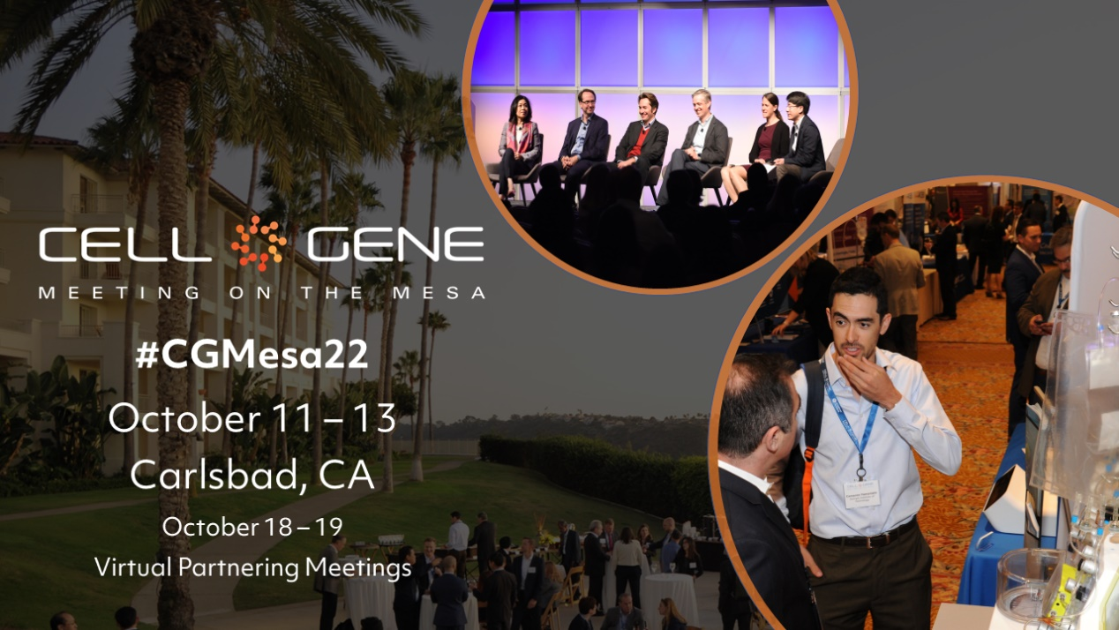

Email Signature Banners:

Use the following banner in your email signature to let you colleagues, clients, and partners know that you’re attending! Right click on the banner and click “Save as Picture,” or download it here.

