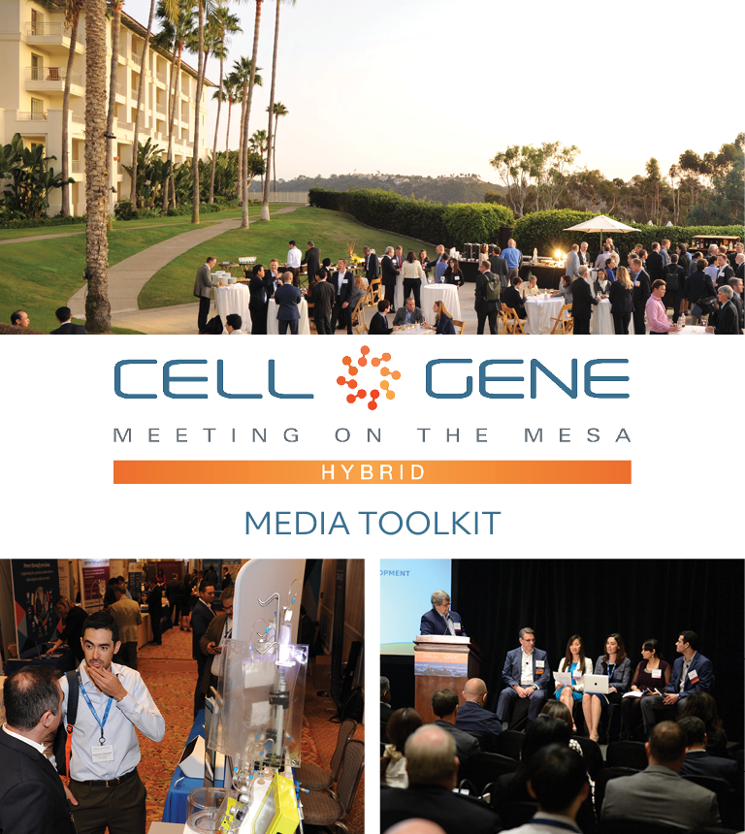

October 11 – 13, 2022 | Carlsbad, CA
#CGMesa22
What is this Toolkit?

Thank you for joining us this year! We’re looking forward to welcoming you to the cell and gene therapy sector’s leading gathering in North America.

This toolkit is meant to help you get the most out of #CGMesa22. Whether it’s showcasing your panel, posting something you learned, or just showing off how much fun you are having, sharing your experience online will enhance your engagement with the rest of the conference. Using social media will also help you discover opportunities to virtually connect with new colleagues and expand your network.

How to Follow the Conversation

First, make sure you’re following the Alliance for Regenerative Medicine (ARM) to stay up to date on all the action. We’ll be live on social media throughout the meeting, and we have some exciting teasers we’ll be sharing in the weeks leading up.

Twitter: @alliancerm (https://twitter.com/alliancerm)
LinkedIn: Alliance for Regenerative Medicine (https://www.linkedin.com/company/alliancerm)

Follow the conversation with #CGMesa22. Other related hashtags are #RegenerativeMedicine, #CellTherapy and #GeneTherapy. If you plan on using a different hashtag, give us a tweet to let us know!

Share Your Experience Online

There are many ways you can engage digitally at #CGMesa22!

- Like taking photographs? Post photos with your fellow panelists.
- Are you a wordsmith? Give a readout of your panel session.
- Are you a talker? Record yourself sharing your favorite moments from the day. (Just don’t interrupt the speakers, please!)
  - Please note, if you plan to share any video recordings of the live sessions, please contact Adam Wolf (awolf@alliancerm.org) for prior approval.

We’ve included some suggested text for tweets and posts below to get you started – but feel free to draft your own! We’ve included a banner for the conference in this media kit that you can include with your posts.

Activate Others

Remember to use the hashtag #CGMesa22 and tag the Alliance for Regenerative Medicine (@alliancerm on Twitter and @Alliance for Regenerative Medicine on LinkedIn). Also tag your fellow colleagues and panelists to include them in the conversation!

Whether you’re joining us in-person or virtually this year, we’re excited to bring you both expert insights and unmatched partnering opportunities.

If you have any questions about this media toolkit, please reach out to Adam Wolf (awolf@alliancerm.org).

Suggested Posts for Twitter & LinkedIn
Date | Twitter | LinkedIn
October 3-7  Personal social | I’m looking forward to participating in a panel on [panel title] at @alliancerm’s #CGMesa22 next week! I hope you’ll join me at the conference, taking place Oct 11-13: https://meetingonthemesa.com/ | I’m excited to be participating in a panel on [panel title] at @Alliance for Regenerative Medicine’s Cell & Gene Meeting on the Mesa! With in-person programming October 11-13 and virtual partnering October 18-19, this hybrid meeting brings together senior executives & top decision-makers to advance this cutting-edge sector. Don’t miss out – for more information, visit https://bit.ly/39kYQIR.  #CGMesa22 #RegenerativeMedicine
October 3-7  Company social | [Name] will be participating in a panel on [panel title] at @alliancerm’s #CGMesa22 next week! Don’t miss out – register for this meeting taking place Oct 11-13 & virtually on Oct. 18-19: https://meetingonthemesa.com/ | [Name] will be participating in a panel on [panel title] at @Alliance for Regenerative Medicine’s Cell & Gene Meeting on the Mesa! With in-person programming October 11-13 and virtual partnering October 18-19, this hybrid meeting brings together senior executives & top decision-makers to advance this cutting-edge sector. Don’t miss out – for more information, visit https://bit.ly/39kYQIR.  #CGMesa22 #RegenerativeMedicine
October 10  Personal social | I’m excited to discuss [panel title] this week on [date] at @alliancerm’s #CGMesa22. Check out our session and see the full agenda: https://meetingonthemesa.com/ | I’m excited to discuss [panel title] this week at @Alliance for Regenerative Medicine’s Cell & Gene Meeting on the Mesa on [date]. Check out our session and see the full agenda: https://bit.ly/39kYQIR.  #CGMesa22 #RegenerativeMedicine
October 10  Company social | Excited for the kick-off of @alliancerm’s #CGMesa22 tomorrow! Check out the exciting line up of content during the conference – including a panel on [panel title] featuring [company speaker]: https://meetingonthemesa.com/ | We’re excited for the kick-off of @Alliance for Regenerative Medicine’s Cell & Gene Meeting on the Mesa tomorrow! Check out the exciting line up of content from key policymakers, industry leaders, and more – including a panel on [panel title] featuring [company speaker]: https://bit.ly/301fidI  #CGMesa22 #RegenerativeMedicine
Day of panel  Company social | [Company speaker] is discussing [panel title] in a panel at @alliancerm’s Cell & Gene Meeting on the Mesa! Tune in at [time] today: https://meetingonthemesa.com/ #CGMesa22 | [Company speaker] is discussing [panel title] in a panel at @Alliance for Regenerative Medicine’s Cell & Gene Meeting on the Mesa! Tune in at [time] today: https://meetingonthemesa.com/  #CGMesa22 #RegenerativeMedicine
Day of panel  Personal social | It’s great to have the opportunity to discuss [panel title] with my colleagues at @alliancerm’s #CGMesa22! If you missed the panel, watch the recording online: https://meetingonthemesa.com/ | It’s great to have the opportunity to discuss [panel title] with my colleagues at @Alliance for Regenerative Medicine’s Cell & Gene Meeting on the Mesa! If you missed the panel, watch the recording online: https://meetingonthemesa.com/  #CGMesa22 #RegenerativeMedicine
October 13  Personal social | It is already the final day of @alliancerm’s #CGMesa22!  I was so thrilled to hear from cell and gene therapy sector leaders this week! Here are some of my favorite moments.  [Attached 2-4 of your favorite photos from the week] | It is already the final day of @alliancerm’s #CGMesa22!  I was so thrilled to hear from cell and gene therapy sector leaders this week! Here are some of my favorite moments.  [Attached 2-4 of your favorite photos from the week]
Post-meeting  Company social | Content from @alliancerm’s Cell & Gene Meeting on the Mesa will be available for registrants through EOY 2022! Don’t forget to check out [company speaker] in the panel on [panel title]: https://meetingonthemesa.com/ #CGMesa22 | Content from @Alliance for Regenerative Medicine’s Cell & Gene Meeting on the Mesa will be available for registrants through EOY 2022! Don’t forget to check out [company speaker] in the panel on [panel title]: https://meetingonthemesa.com/  #CGMesa22 #RegenerativeMedicine
October 18  Virtual partnering day | I am back online for @alliancerm’s #CGMesa22! With two days of virtual partnering, there’s still time to schedule a meeting with me or our team: https://meetingonthemesa.com/ | I am back online for @Alliance for Regenerative Medicine’s Cell & Gene Meeting on the Mesa! With two days of virtual partnering, there’s still time to schedule a meeting with me or our team: https://meetingonthemesa.com/  #RegenerativeMedicine #CGMesa22

Social Media Posts:

Use the following banner with your Twitter and LinkedIn posts! Right click on the banner and click “Save as Picture,” or download it here.

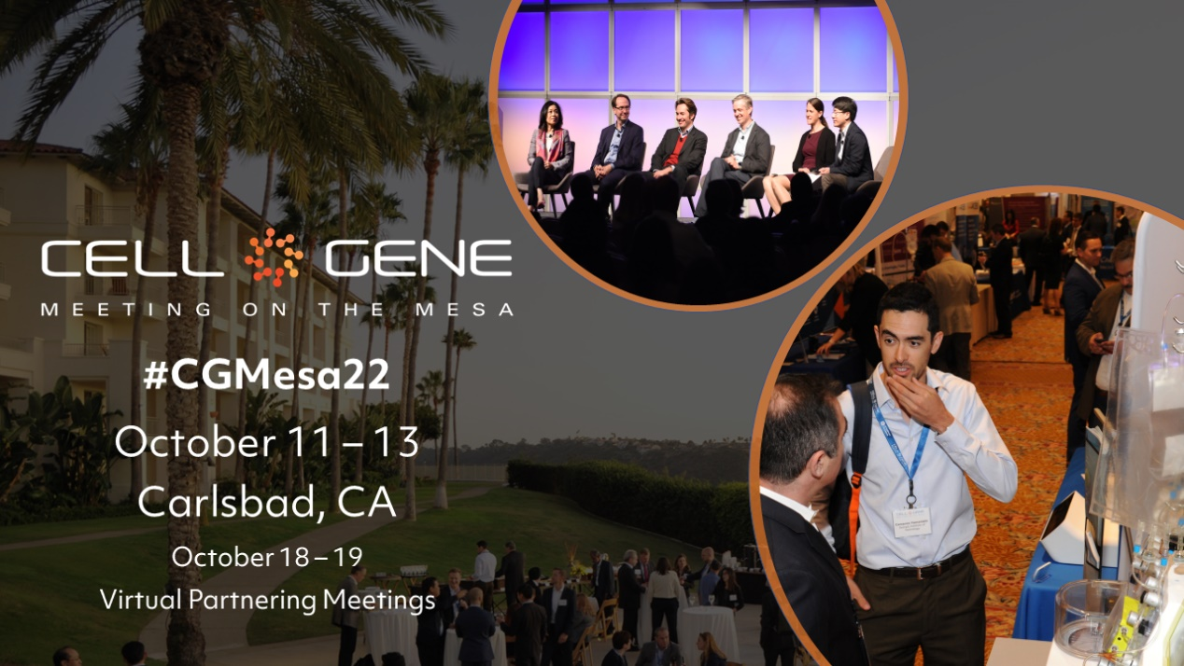

Email Signature Banners:

Use the following banner in your email signature to let you colleagues, clients, and partners know that you’re attending! Right click on the banner and click “Save as Picture,” or download it here.

