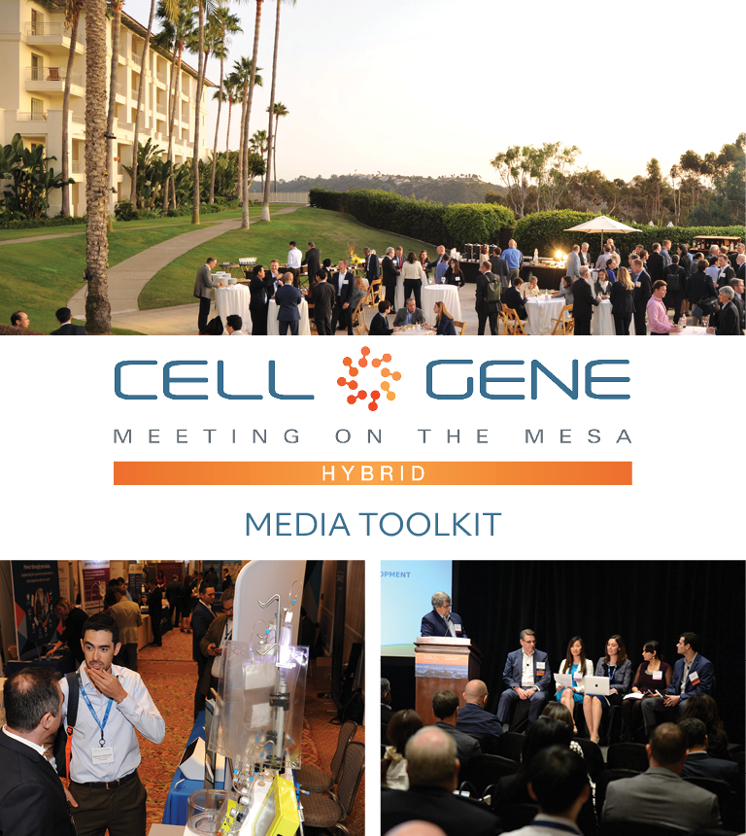

October 11 – 13, 2022 | Carlsbad, CA
#CGMesa22
What is this Toolkit?

Thank you sponsoring the 2022 Cell and Gene Meeting on the Mesa! We’re looking forward to welcoming you to the cell and gene therapy sector’s leading gathering in North America.

This toolkit is meant to help you get the most out of #CGMesa22. Whether it’s showcasing your panel, posting something you learned, or showing off your exhibit booth, sharing your experience online will enhance your engagement with the rest of the conference. Using social media will also help you discover opportunities to virtually connect with new colleagues and expand your network.

How to Follow the Conversation

First, make sure you’re following the Alliance for Regenerative Medicine (ARM) to stay up to date on all the action. We’ll be live on social media throughout the meeting, and we have some exciting teasers we’ll be sharing in the weeks leading up.

Twitter: @alliancerm (https://twitter.com/alliancerm)
LinkedIn: Alliance for Regenerative Medicine (https://www.linkedin.com/company/alliancerm)

Follow the conversation with #CGMesa22. Other related hashtags are #RegenerativeMedicine, #CellTherapy and #GeneTherapy. If you plan on using a different hashtag, give us a tweet to let us know!

Share Your Experience Online

There are many ways you can engage digitally at #CGMesa22!

- Like taking photographs? Post daily photos of your favorite moments.
- Are you a wordsmith? Give a readout of your favorite sessions.
- Are you a talker? Record yourself sharing your favorite moments from the day. (Just don’t interrupt the speakers, please!)
  - Please note, if you plan to share any video recordings of the live sessions, please contact Adam Wolf (awolf@alliancerm.org) for prior approval.

We’ve included some suggested text for tweets and posts below to get you started – but feel free to draft your own! We’ve included a banner for the conference in this media kit that you can include with your posts.

Activate Others

Remember to use the hashtag #CGMesa22 and tag the Alliance for Regenerative Medicine (@alliancerm on Twitter and @Alliance for Regenerative Medicine on LinkedIn). Also tag your fellow colleagues to include them in the conversation!

Whether you’re joining us in-person or virtually this year, we’re excited to bring you both expert insights and unmatched partnering opportunities.

If you have any questions about this media toolkit, please reach out to Adam Wolf (awolf@alliancerm.org).

Suggested Posts for Twitter & LinkedIn
Date | Twitter | LinkedIn
October 3-7 | [X] days until @alliancerm’s #CGMesa22! The hybrid event includes in-person programming Oct. 11-13 & virtual partnering Oct. 18-19. Join us at the cell and gene therapy sector's foremost annual conference: https://meetingonthemesa.com/ | [x] days until @Alliance for Regenerative Medicine’s 2022 Cell & Gene Meeting on the Mesa! We are thrilled to sponsor the regenerative medicine and advanced therapies sector’s leading event in North America. Interested in joining? Learn more here: https://meetingonthemesa.com/  #CGMesa22 #RegenerativeMedicine
October 3-7 | [Company] is sponsoring @alliancerm’s #CGMesa22! 3,000+ virtual and in-person partnering meetings will take place Oct. 11-13 & 18-19. Register to set up a meeting with our team: https://meetingonthemesa.com/ | [Company] is sponsoring the @Alliance for Regenerative Medicine’s Cell & Gene Meeting on the Mesa! Organizers are expecting 3,000+ virtual and in-person partnering meetings, which will take place October 11-13, with virtual partnering October 18-19. Register to set up a meeting with our team now! For more information, visit https://meetingonthemesa.com/  #CGMesa22 #RegenerativeMedicine
October 10 | Excited for Day 1 of @alliancerm’s Cell & Gene Meeting on the Mesa tomorrow! Check out the action-packed line featuring leading experts tackling the most pressing issues in cell and gene therapies: https://meetingonthemesa.com/ #CGMesa22 | Excited for Day 1 of the @Alliance for Regenerative Medicine’s Cell & Gene Meeting on the Mesa tomorrow! This conference brings together senior executives & top decision-makers to advance the cell and gene therapy sector. Check out the action-packed agenda featuring key policymakers, industry leaders, and more: https://meetingonthemesa.com/  #CGMesa22 #RegenerativeMedicine
October 11 | Good morning fellow #CGMesa22 attendees! Day 1 of @alliancerm’s Cell & Gene Meeting on the Mesa is underway. Looking forward to seeing everyone this week. I am most excited for [Give a shoutout to your most anticipated panel].  [Upload a photo or selfie!] | Good morning fellow conference attendees! Day 1 of the @Alliance for Regenerative Medicine’s Cell & Gene Meeting on the Mesa is underway. Looking forward to seeing everyone this week. I am most excited for [Give a shoutout to your most anticipated panel].  #CGMesa22 #RegenerativeMedicine  [Upload a photo or selfie!]
October 12 | [Company] is a proud sponsor of @alliancerm’s Cell & Gene Meeting on the Mesa! Our team is available – check out the partnering system & request a meeting today! #CGMesa22 | [Company] is a proud sponsor of @Alliance for Regenerative Medicine’s Cell & Gene Meeting on the Mesa #CGMesa22! Our team is available – check out the partnering system and request a meeting to learn how we can work together!  #RegenerativeMedicine
October 13 | It is already the final day of @alliancerm’s #CGMesa22!  I was so thrilled to hear from cell and gene therapy sector leaders this week! Here are some of my favorite moments.  [Attach 2-4 of your favorite photos from the week] | It is already the final day of @alliancerm’s #CGMesa22!  I was so thrilled to hear from cell and gene therapy sector leaders this week! Here are some of my favorite moments.  [Attach 2-4 of your favorite photos from the week]
October 18  Virtual partnering day | We’re back online for @alliancerm’s #CGMesa22! With two days of virtual partnering, there’s still time to schedule a meeting with our team: https://meetingonthemesa.com/ | We’re back online for @Alliance for Regenerative Medicine’s Cell & Gene Meeting on the Mesa! With two days of virtual partnering, there’s still time to schedule a meeting with our team: https://meetingonthemesa.com/  #RegenerativeMedicine #CGMesa22
October 19  Virtual partnering day | It's the final day of virtual partnering at @alliancerm's #CGMesa22. Thank you to everyone who made this conference a success! Recordings are available online if you missed any of the insightful content: https://meetingonthemesa.com/ | It’s the final day of virtual partnering at @Alliance for Regenerative Medicine’s Cell & Gene Meeting on the Mesa! Thank you to the presenters, organizers, and to our fellow attendees for making this conference a success! Recordings are available online if you missed any of the insightful content: https://meetingonthemesa.com/  #CGMesa22 #RegenerativeMedicine

Social Media Posts:

Use the following banners with your Twitter and LinkedIn posts! Right click on the banner and click “Save as Picture.” You can also easily generate custom banners featuring your company’s logo – download our Sponsor media kit banners here for instructions.

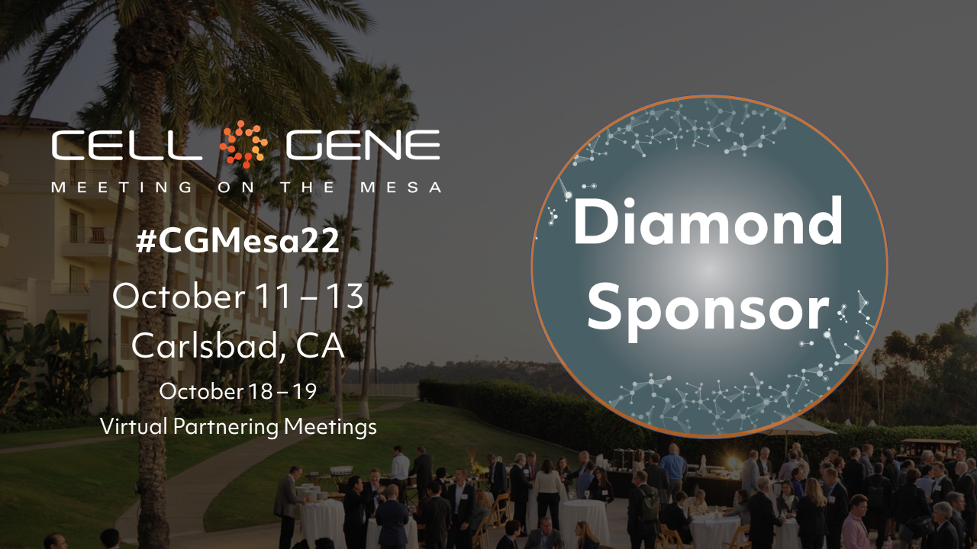

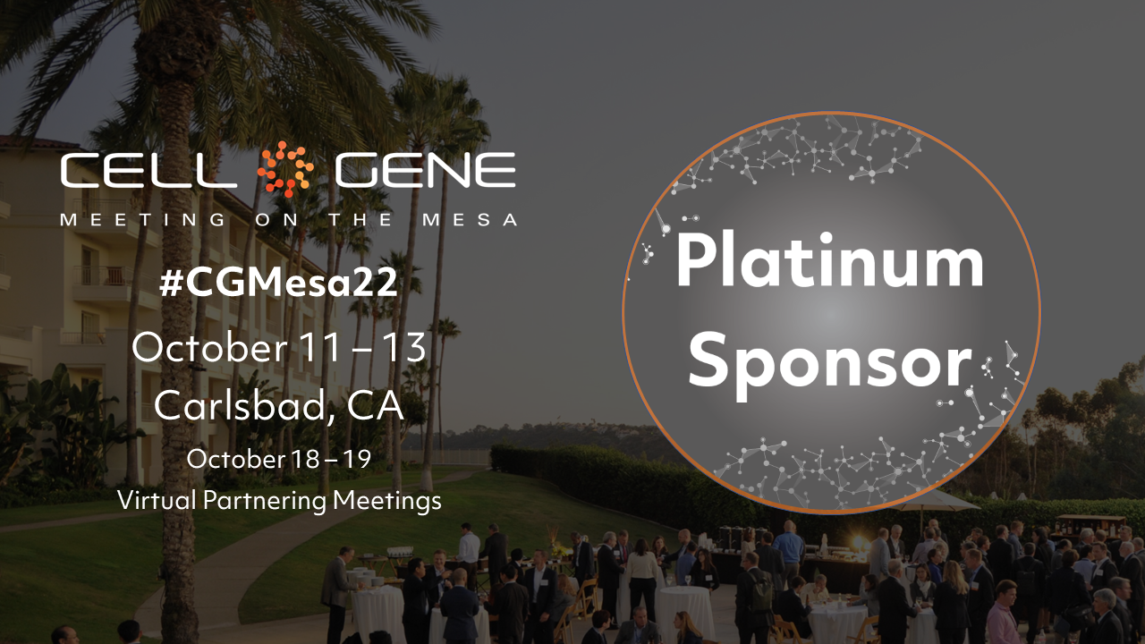
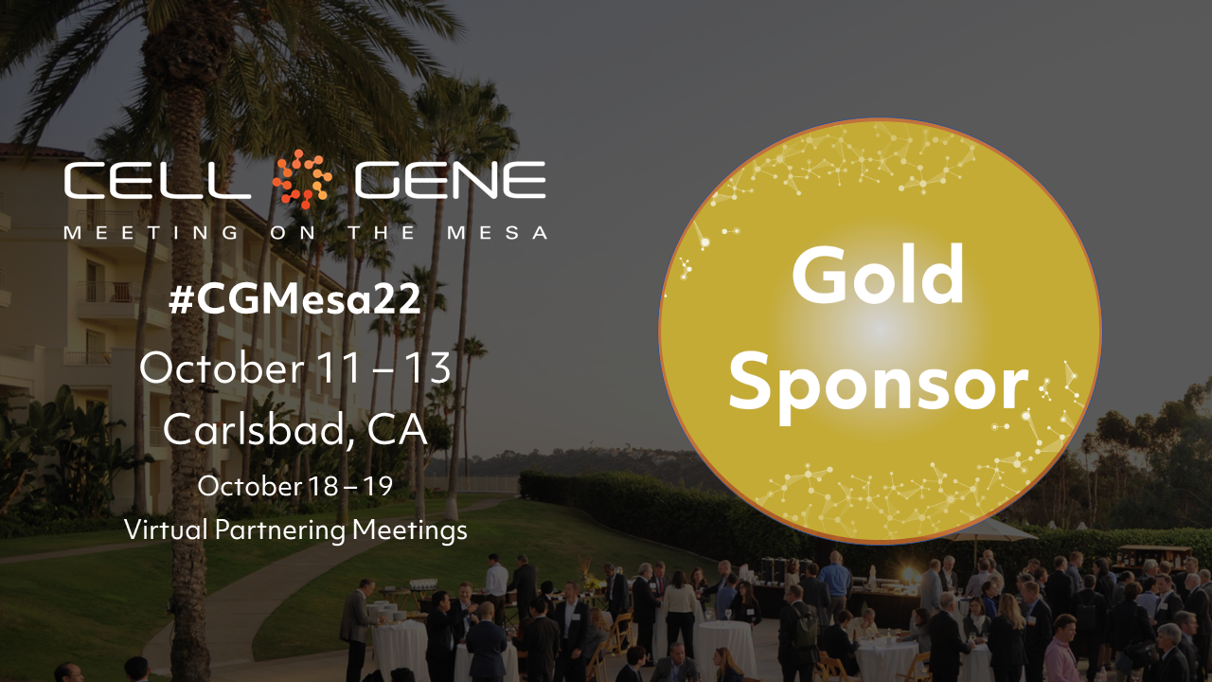

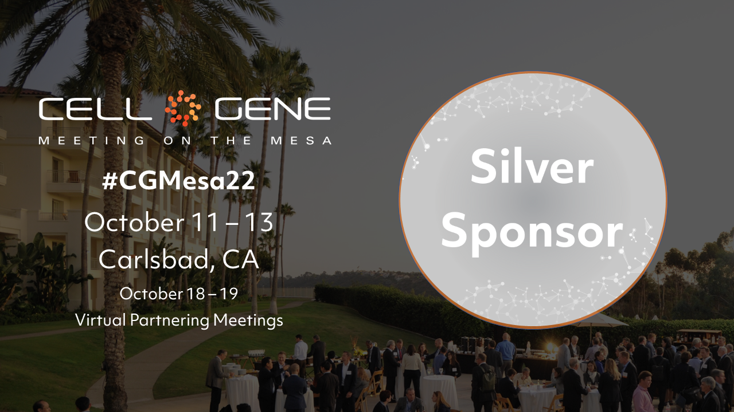

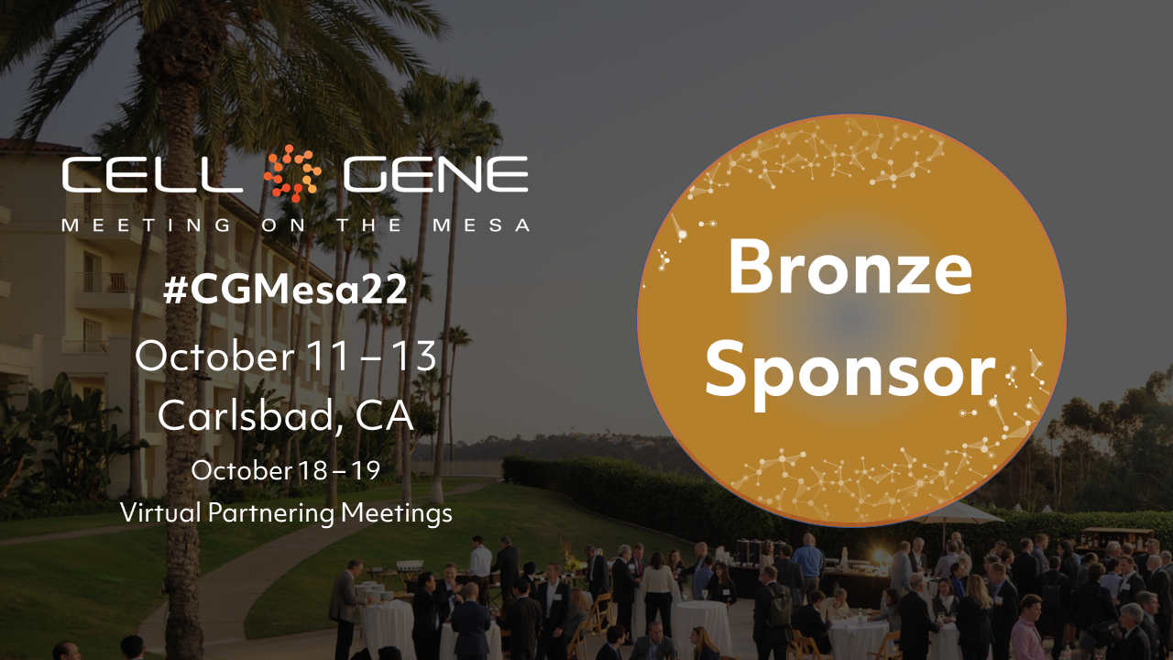

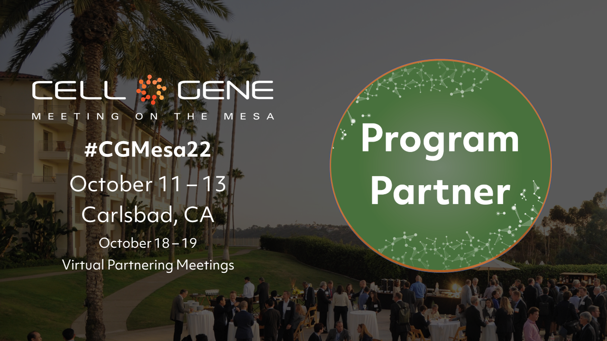

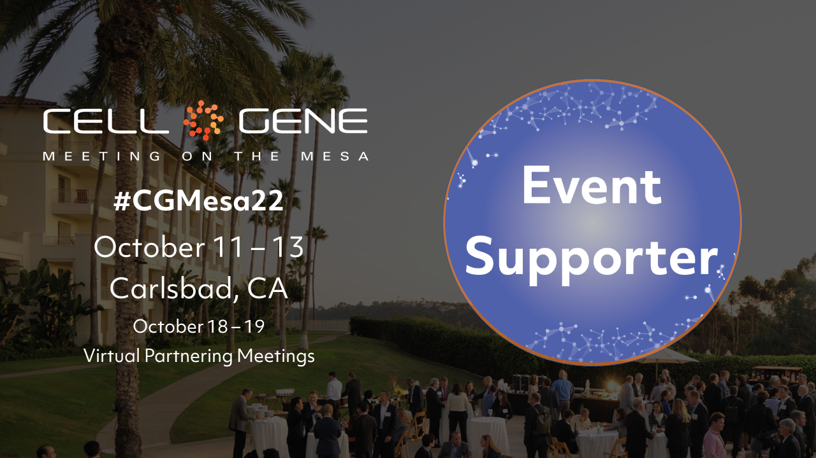

Email Signature Banners:

Use the following banner in your email signature to let you colleagues, clients, and partners know that you’re attending! Right click on the banner and click “Save as Picture,” or download it here.

