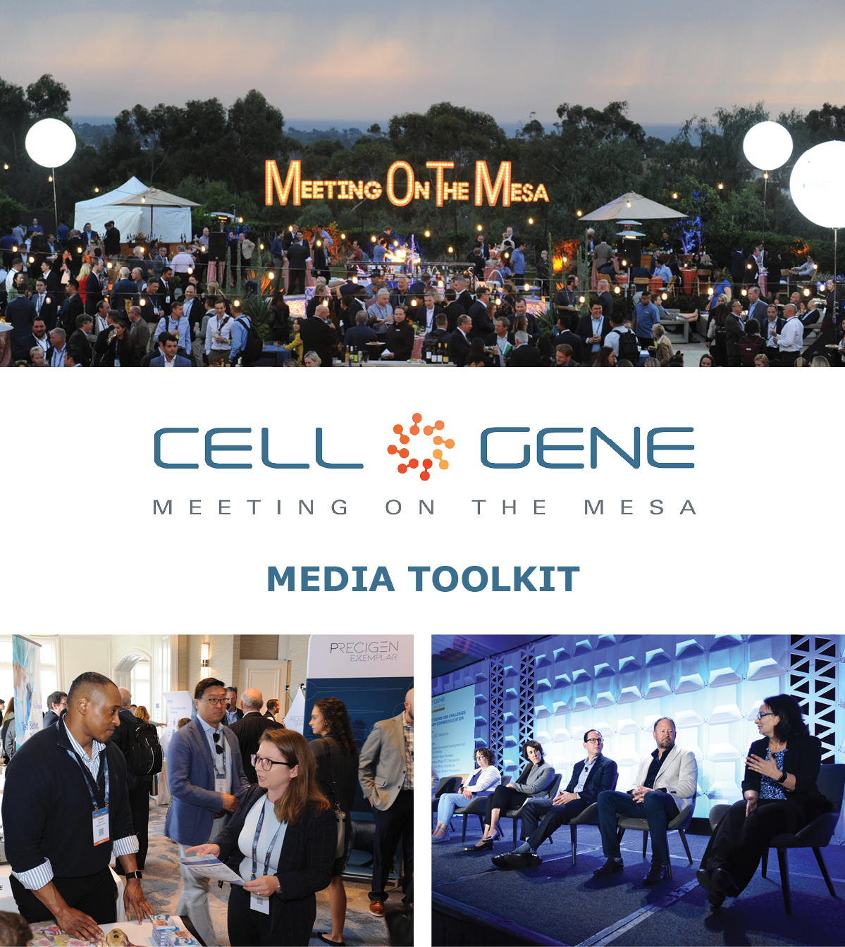

October 10 – 12, 2023 | Carlsbad, CA
#CGMesa23
What is this Toolkit?

This toolkit is meant to help you get the most out of #CGMesa23. Whether showcasing your company presentation, tweeting something you learned, or posting your favorite photo, sharing your experience online will enhance your engagement with the rest of the conference. Social media will also help you discover opportunities to connect with new colleagues and expand your network virtually.

How to Follow the Conversation

Follow the conference conversation with #CGMesa23.

Other related hashtags are #CellandGeneTherapy, #CellTherapy, and #GeneTherapy.

If you plan on using a different hashtag, give us a tweet to let us know!

Ensure you follow the Alliance for Regenerative Medicine (ARM) to stay current on all the action. We’ll be live on social media throughout the meeting, and we have some exciting teasers we’ll be sharing in the weeks leading up to the conference.

Twitter: @alliancerm (https://twitter.com/alliancerm)
LinkedIn: Alliance for Regenerative Medicine (https://www.linkedin.com/company/alliancerm)

Share Your Experience Online

There are many ways you can engage digitally at #CGMesa23!

- Like taking photographs? Post daily photos of your favorite moments.
- Are you a wordsmith? Give a readout of your favorite sessions.
- Are you a talker? Record yourself sharing your favorite moments from the day. (Don’t interrupt the speakers, please!)
  - Please note: if you plan to share any video recordings of the live sessions, please get in touch with Adam Wolf (awolf@alliancerm.org) for prior approval.

We’ve included some suggested text for tweets and posts below to get you started – but feel free to draft your own! We’ve also included a banner for the conference in this media kit that you can include with your posts.

Activate Others

- Remember to use the hashtag #CGMesa23
- Tag the Alliance for Regenerative Medicine (@alliancerm on Twitter and @Alliance for Regenerative Medicine on LinkedIn)
- Tag your colleagues to include them in the conversation!
If you have any questions about this media toolkit, please contact Adam Wolf (awolf@alliancerm.org).

Suggested Posts for Twitter & LinkedIn

Date | Twitter | LinkedIn
Prior to the event | [X] days until @alliancerm’s #CGMesa23! Our team looks forward to connecting with senior executives and top stakeholders Oct 10-12 to tackle the most pressing issues in cell and gene therapies.  Learn more: https://meetingonthemesa.com/  See you in California! | [X] days until @Alliance for Regenerative Medicine’s #CGMesa23! Our team looks forward to connecting with senior executives and top stakeholders Oct 10-12 to tackle the most pressing issues in cell and gene therapies.  Learn more: https://meetingonthemesa.com/  See you in California!
Posts during the Conference

October 9 | Our team is excited for Day 1 of @alliancerm’s #CGMesa23 tomorrow! Check out the action-packed agenda - including a presentation from [company]. https://meetingonthemesa.com/  #CGMesa23 | We’re excited for Day 1 of the @Alliance for Regenerative Medicine’s Cell & Gene Meeting on the Mesa tomorrow! Check out the action-packed agenda featuring leading experts and senior leaders from the industry – including a presentation from [Company]. https://meetingonthemesa.com/  #CGMesa23 #cellandgenetherapy
October 9 | [Company]’s team is on-site in beautiful Southern California for #CGMesa23. We look forward to the action-packed lineup featuring leading experts tackling the most pressing issues in cell and gene therapies: www.meetingonthemesa.com  [Have your team upload a photo or selfie!] | [Company]’s team is on-site in beautiful Southern California for #CGMesa23. We look forward to the action-packed lineup featuring leading experts tackling the most pressing issues in cell and gene therapies: www.meetingonthemesa.com  [Have your team upload a photo or selfie!]
October 10 | Good morning fellow #CGMesa23 attendees! Day 1 of the conference is underway. We look forward to seeing everyone this week – don’t miss [Give a shoutout to your company presenter]  [Upload a photo or selfie!] | Good morning fellow #CGMesa23 attendees! Day 1 of the conference is underway. We look forward to seeing everyone this week – don’t miss [Give a shoutout to your company presenter]  [Upload a photo or selfie!]
October 10  (Networking bash) | Our team connected with some amazing cell and gene therapy professionals at the #CGMesa23 networking bash tonight.  [Have your team send photos of the bash!] | Our team connected with some amazing cell and gene therapy professionals at the #CGMesa23 networking bash tonight.  [Have your team send photos of the bash!]
October 10-12 | We’re on the edge of our seats! [Name] shared updates from [Company] at @alliancerm’s Cell & Gene Meeting on the Mesa!  Check out the full lineup of speakers and presentations: https://meetingonthemesa.com/  #CGMesa23 | We’re on the edge of our seats! [Name] shared updates from [Company] at @Alliance for Regenerative Medicine’s Cell & Gene Meeting on the Mesa!  Check out the full lineup of speakers and presentations: https://meetingonthemesa.com/  #CGMesa23 #cellandgenetherapy
October 12 | It is already the final day of #CGMesa23, and what a fantastic week it has been!  Our team was thrilled to hear from cell and gene therapy sector leaders this week. Here are some of our favorite moments.  [Attach 2-4 of your favorite photos from the week] | It is already the final day of #CGMesa23, and what a fantastic week it has been!  Our team was thrilled to hear from cell and gene therapy sector leaders this week. Here are some of our favorite moments.  [Attach 2-4 of your favorite photos from the week]

Social Media Posts:

Use the following banner with your Twitter and LinkedIn posts! Right-click on the banner and click “Save as Picture” or download it here.

