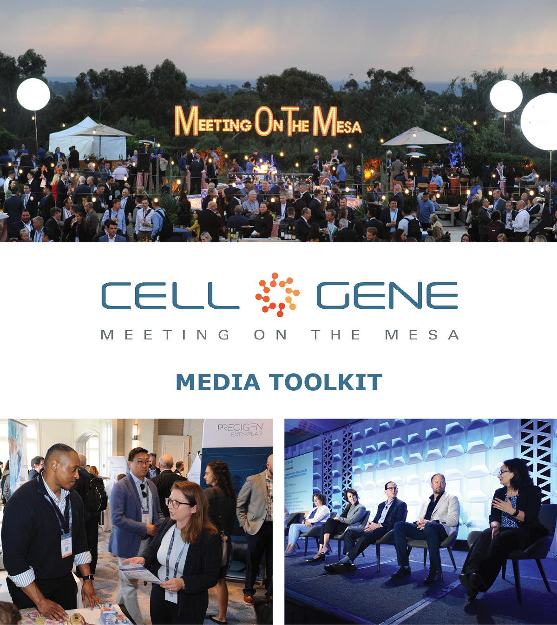

October 10 – 12, 2023 | Carlsbad, CA
#CGMesa23
What is this Toolkit?

This toolkit is meant to help you get the most out of #CGMesa23. Whether showcasing your panel, tweeting something you learned, or posting your favorite photo, sharing your experience online will enhance your engagement with the rest of the conference. Social media will also help you discover opportunities to connect with new colleagues and expand your network virtually.

How to Follow the Conversation

Follow the conference conversation with #CGMesa23.

Other related hashtags are #CellandGeneTherapy, #CellTherapy, and #GeneTherapy.

If you plan on using a different hashtag, give us a tweet to let us know!

Ensure you follow the Alliance for Regenerative Medicine (ARM) to stay current on all the action. We’ll be live on social media throughout the meeting, and we have some exciting teasers we’ll be sharing in the weeks leading up to the conference.

Twitter: @alliancerm (https://twitter.com/alliancerm)
LinkedIn: Alliance for Regenerative Medicine (https://www.linkedin.com/company/alliancerm)

Share Your Experience Online

There are many ways you can engage digitally at #CGMesa23!

- Like taking photographs? Post daily photos of your favorite moments.
- Are you a wordsmith? Give a readout of your favorite sessions.
- Are you a talker? Record yourself sharing your favorite moments from the day. (Don’t interrupt the speakers, please!)
  - Please note: if you plan to share any video recordings of the live sessions, please get in touch with Adam Wolf (awolf@alliancerm.org) for prior approval.

We’ve included some suggested text for tweets and posts below to get you started – but feel free to draft your own! We’ve also included a banner for the conference in this media kit that you can include with your posts.

Activate Others

- Remember to use the hashtag #CGMesa23
- Tag the Alliance for Regenerative Medicine (@alliancerm on Twitter and @Alliance for Regenerative Medicine on LinkedIn)
- Tag your colleagues to include them in the conversation!
If you have any questions about this media toolkit, please contact Adam Wolf (awolf@alliancerm.org).

Suggested Posts for Twitter & LinkedIn

Date | Twitter | LinkedIn
Prior to the event | [X] days until @alliancerm’s #CGMesa23! Looking forward to connecting with senior executives and top stakeholders Oct 10-12 to tackle the most pressing issues in cell and gene therapies.  Learn more: https://meetingonthemesa.com/  See you in California! | [X] days until @Alliance for Regenerative Medicine’s #CGMesa23! Looking forward to connecting with senior executives and top stakeholders Oct 10-12 to tackle the most pressing issues in cell and gene therapies.  Learn more: https://meetingonthemesa.com/  See you in California!
Prior to the event | I am excited to share that I’ll participate on a panel about [panel title or summary] on [date] at @alliancerm’s #CGMesa23.  Be sure to mark it on your agenda and don’t miss out! https://meetingonthemesa.com/ | I am excited to share that I’ll participate on a panel about [panel title or summary] on [date] at the @Alliance for Regenerative Medicine’s #CGMesa23. I am honored to speak alongside [tag your panel’s other speakers].  Be sure to mark it on your agenda and don’t miss out! https://meetingonthemesa.com/
Posts during the Conference

October 9  Personal social | I’m excited to discuss [panel title] on [date] this week at @alliancerm’s #CGMesa23. Check out our session and see the full agenda: https://meetingonthemesa.com/ | I’m excited to discuss [panel title] this week at @Alliance for Regenerative Medicine’s Cell & Gene Meeting on the Mesa on [date]. Check out our session and see the full agenda: https://meetingonthemesa.com/  #CGMesa23 #cellandgenetherapy
October 9  Company social | Excited for the kick-off of @alliancerm’s #CGMesa23 tomorrow! Check out the thrilling lineup of content during the conference – including a panel on [panel title] featuring [company speaker]: https://meetingonthemesa.com/ | We’re excited for the kick-off of @Alliance for Regenerative Medicine’s Cell & Gene Meeting on the Mesa tomorrow! Check out the thrilling lineup of content from key policymakers, industry leaders, and more – including a panel on [panel title] featuring [company speaker]: https://meetingonthemesa.com/  #CGMesa23 #cellandgenetherapy
Day of panel  Company social | [Company speaker] is discussing [panel title] in a panel at @alliancerm’s Cell & Gene Meeting on the Mesa! Tune in at [time] today: https://meetingonthemesa.com/ #CGMesa23 | [Company speaker] is discussing [panel title] in a panel at @Alliance for Regenerative Medicine’s Cell & Gene Meeting on the Mesa! Tune in at [time] PT today: https://meetingonthemesa.com/  #CGMesa23 #cellandgenetherapy
Day of panel  Personal social | It’s great to have the opportunity to discuss [panel title] with my colleagues at @alliancerm’s #CGMesa23! Attendees who missed the panel, watch the recording online: https://meetingonthemesa.com/ | It’s great to have the opportunity to discuss [panel title] with my colleagues at @Alliance for Regenerative Medicine’s Cell & Gene Meeting on the Mesa! Attendees who missed the panel can watch the recording online: https://meetingonthemesa.com/  #CGMesa23 #cellandgenetherapy
October 12 | It is already the final day of #CGMesa23, and what a fantastic week it has been!  I was thrilled to hear from cell and gene therapy sector leaders this week. Here are some of my favorite moments.  [Attach 2-4 of your favorite photos from the week] | It is already the final day of #CGMesa23, and what a fantastic week it has been!  I was thrilled to hear from cell and gene therapy sector leaders this week. Here are some of my favorite moments.  [Attach 2-4 of your favorite photos from the week]

Social Media Posts:

Use the following banner with your Twitter and LinkedIn posts! Right-click on the banner and click “Save as Picture” or download it here.

