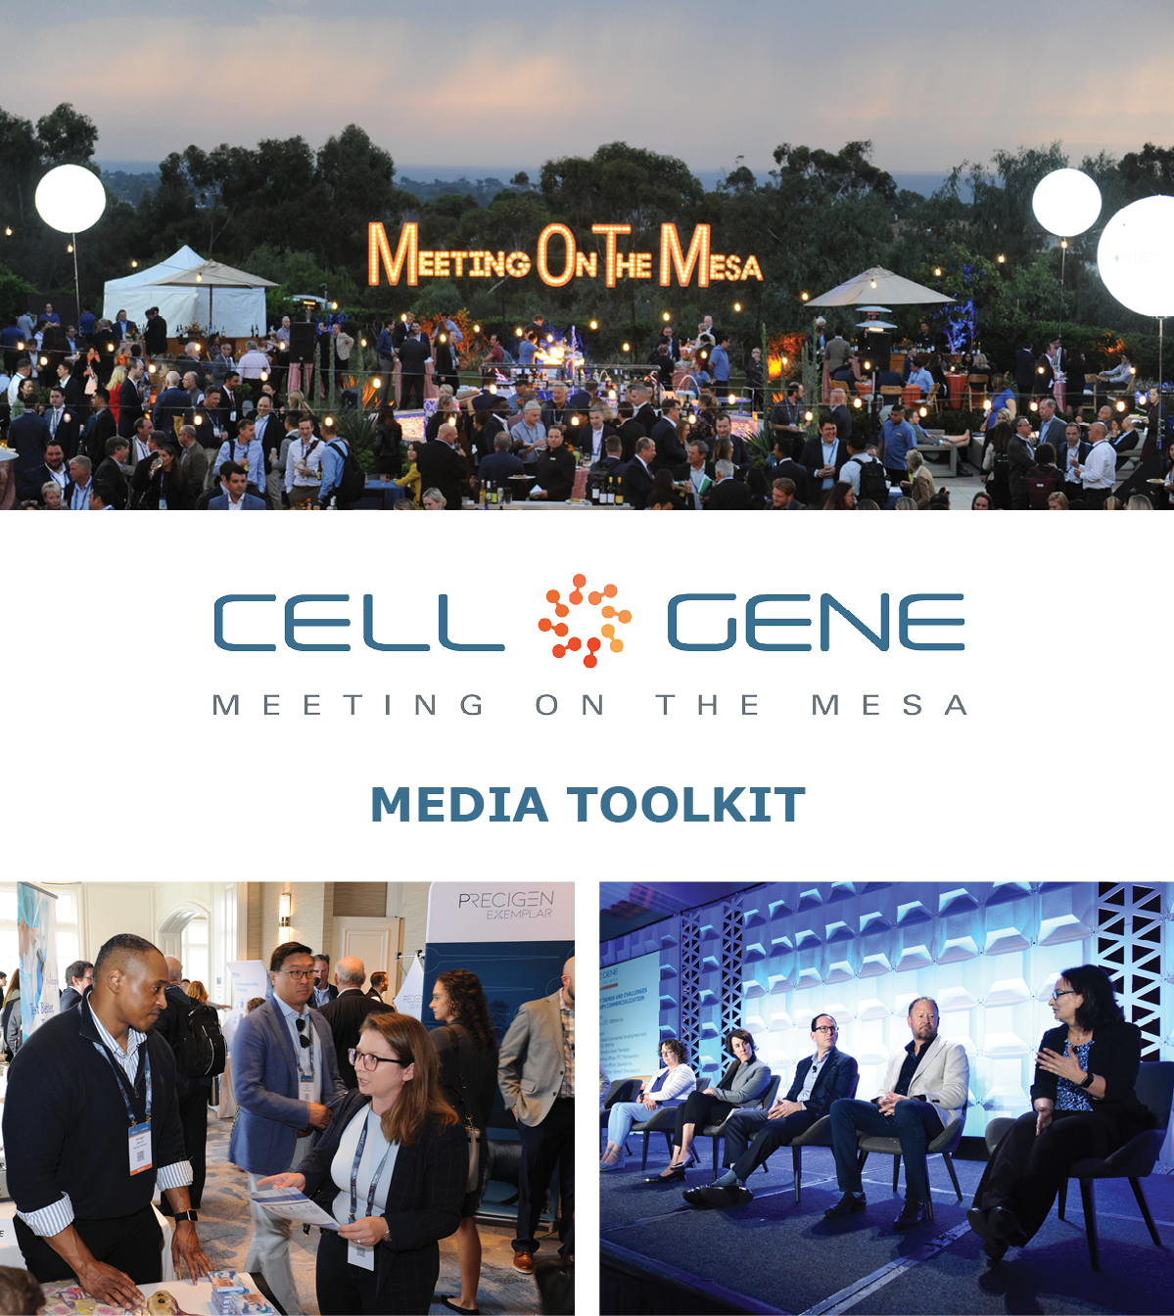

October 10 – 12, 2023 | Carlsbad, CA
#CGMesa23
What is this Toolkit?

This toolkit is meant to help you get the most out of #CGMesa23. Whether showcasing your panel, posting something you learned, or showing off your exhibit booth, sharing your experience online will enhance your engagement with the rest of the conference. Social media will also help you discover opportunities to connect with new colleagues and expand your network virtually.

How to Follow the Conversation

Follow the conference conversation with #CGMesa23.

Other related hashtags are #CellandGeneTherapy, #CellTherapy, and #GeneTherapy.

If you plan on using a different hashtag, give us a tweet to let us know!

Ensure you’re following the Alliance for Regenerative Medicine (ARM) to stay current on all the action. We’ll be live on social media throughout the meeting, and we have some exciting teasers we’ll be sharing in the weeks leading up to the conference.

Twitter: @alliancerm (https://twitter.com/alliancerm)
LinkedIn: Alliance for Regenerative Medicine (https://www.linkedin.com/company/alliancerm)

Share Your Experience Online

There are many ways you can engage digitally at #CGMesa23!

- Like taking photographs? Post daily photos of your favorite moments.
- Are you a wordsmith? Give a readout of your favorite sessions.
- Are you a talker? Record yourself sharing your favorite moments from the day. (Don’t interrupt the speakers, please!)
  - Please note: if you plan to share any video recordings of the live sessions, please contact Adam Wolf (awolf@alliancerm.org) for prior approval.

We’ve included some suggested text for tweets and posts below to get you started – but feel free to draft your own! We’ve also included banners for the conference in this media kit that you can include with your posts.

Activate Others

- Remember to use the hashtag #CGMesa23
- Tag the Alliance for Regenerative Medicine (@alliancerm on Twitter and @Alliance for Regenerative Medicine on LinkedIn)
- Tag your colleagues to include them in the conversation!
If you have any questions about this media toolkit, please get in touch with Adam Wolf (awolf@alliancerm.org).

Suggested Posts for Twitter & LinkedIn

Date | Twitter | LinkedIn
Prior to the event | [Company] is sponsoring @alliancerm’s #CGMesa23, happening October 10-12! We look forward to connecting with senior executives and top stakeholders to tackle the most pressing issues in cell and gene therapies.  Learn more: https://meetingonthemesa.com/  See you in California! | [Company] is sponsoring the @Alliance for Regenerative Medicine’s 2023 Cell and Gene Meeting on the Mesa from October 10 – 12. We look forward to connecting with senior executives and top stakeholders to tackle the most pressing issues in cell and gene therapies.  Learn more: https://meetingonthemesa.com/  See you in California!
Prior to the event | [Company] is proud to sponsor #CGMesa23, North America’s leading gathering of experts & leaders in the cell & gene therapy sector.  We’ll join @alliancerm and others on Oct 10-12 for 3 days exploring the latest challenges, developments, & innovations in #cellandgenetherapy. | [Company] is proud to sponsor #CGMesa23, North America’s leading gathering of experts and leaders in the cell and gene therapy sector.  We’ll join the @Alliance for Regenerative Medicine and others on Oct 10-12 for 3 action-packed days exploring the latest challenges, developments, and innovations in #cellandgenetherapy.
Posts during the Conference

October 9 | Our team is excited for Day 1 of @alliancerm’s #CGMesa23 tomorrow! Check out the action-packed agenda featuring leading experts. https://meetingonthemesa.com/  Check out what our team is up to on the first day. [List the panel your company is on or give the location of the booth if you have one] #CGMesa23 | We’re excited for Day 1 of the @Alliance for Regenerative Medicine’s Cell & Gene Meeting on the Mesa tomorrow! Check out the action-packed agenda featuring leading experts and senior leaders from the industry. https://meetingonthemesa.com/  Check out what our team is up to on the first day. [List the panel your company is on or give the location of the booth if you have one]  #CGMesa23 #cellandgenetherapy
October 9 | [Company]’s team is on-site in beautiful southern California for #CGMesa23. Be sure to check out our booth or set up a partnering meeting with the conference partnering system.  [Upload a photo or selfie!] | [Company]’s team is on-site in beautiful southern California for the Cell & Gene Meeting on the Mesa. Be sure to check out our booth or set up a partnering meeting with the conference partnering system.  #CGMesa23  [Upload a photo or selfie!]
October 10 | Good morning fellow #CGMesa23 attendees! Day 1 of the conference is underway. We look forward to seeing everyone this week. Our team is most excited for [Give a shoutout to your most anticipated panel or event in the day].  [Upload a photo or selfie!] | Good morning fellow #CGMesa23 attendees! Day 1 of the conference is underway. We look forward to seeing everyone this week. Our team is most excited for [Give a shoutout to your most anticipated panel or event in the day]. #cellandgenetherapy  [Upload a photo or selfie!]
October 11 | Rise and shine for day 2 of #CGMesa23.  If you haven’t already, be sure to find our team at [List panel your company is on or give location of booth if you have one]  Check out today’s lineup of speakers and presentations: https://meetingonthemesa.com/ | Rise and shine for day 2 of #CGMesa23.  If you haven’t already, be sure to find our team at [List panel your company is on or give location of booth if you have one]  Check out today’s lineup of speakers and presentations: https://meetingonthemesa.com/
October 12 | It is already the final day of #CGMesa23, and what a fantastic week it has been!  This week, we were thrilled to hear from cell and gene therapy sector leaders! Here are some of my favorite moments.  [Attach 2-4 of your favorite photos from the week] | It is already the final day of #CGMesa23, and what a fantastic week it has been!  This week, we were thrilled to hear from cell and gene therapy sector leaders! Here are some of my favorite moments.  [Attach 2-4 of your favorite photos from the week]

Social Media Posts:

Use the following banners with your Twitter and LinkedIn posts! Right-click on the banner and click “Save as Picture.” You can also quickly generate custom banners featuring your company’s logo – download our Sponsor media kit banners here for instructions.

